Istanbul Aydın University
International Student & Staff Affairs (ISSA)
International Student Union (ISU)

Name & Surname
Faculty/Program
Department

Election Campaign File
2016 - 2017
Context

- ISU Presidency Candidate Application Form (Appendix_1)
- Motivation Letter (Appendix_2)
- Supporters Signature (Minimum 50 International Students) (Appendix_3)
- Elements of an Effective Campaign Plan (Appendix_4)
- The file should be prepared as Picture-1 below.

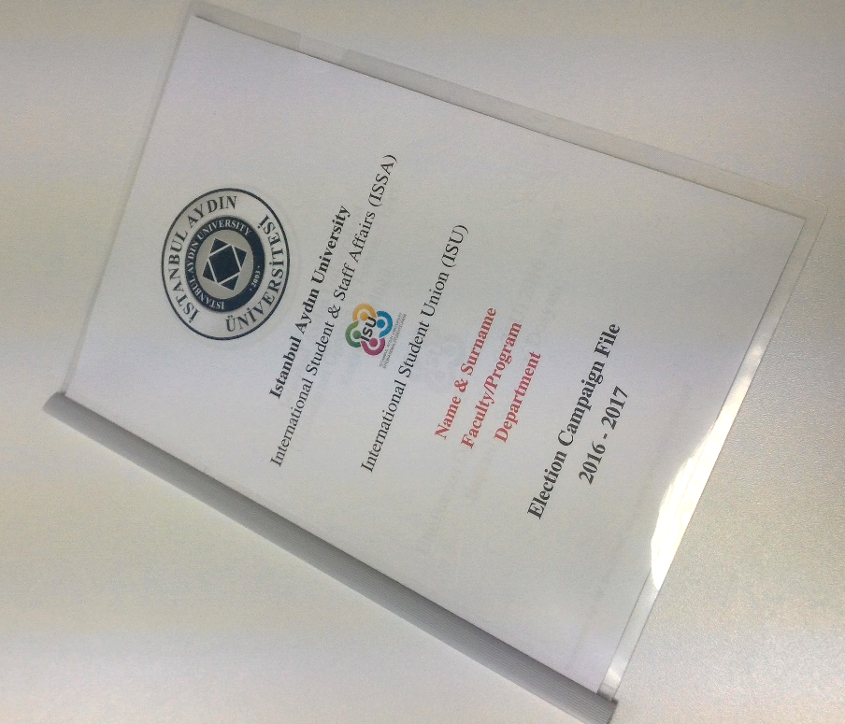
Picture – 1:Draft

