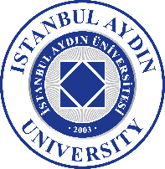
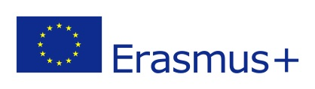
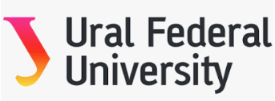

ERASMUS+ PROGRAMME

INTERNATIONAL CREDIT MOBILITY (ICM)

This is to certify that

……………………..
Name of the academician

An academic staff of Istanbul Aydın University
has been accepted to undertake an ERASMUS+ staff teaching mobility
for 5 days between

in

URAL FEDERAL UNIVERSITY, Russian Federation

Title of the Organization, Country

between the following dates

…. / …. / ……. and …. / …. / ……………
Day Month Year Day Month Year

in the Faculty/Department of

……………………………
Title of the unit

The mobility will be carried out in accordance with the Erasmus+ STA agreement that was signed by all parties prior to the mobility and will comprise of minimum 10 teaching hours.

Name and position of the responsible person: ……………………………..

Contact details:(address, telephone, fax, e-mail):
……………………………………..
……………………………………..
………………………………………

_________

Date Signature and Seal

Name and Position of the Signatory

